The year is 3001. Your grandmother is an original settler from Bitter spa, who with her daughter pioneered a green-eyed visionary device and started a movement. Bitter spa for 150 years was remembered as a place that had fit an incredible amount of people safely, a vault with water. Now the entrance to Bitter spa is lost in rows of sniper lines and trapped corridors. Your lineage is your father who went underground and who’s people came from up North from the wastes. Your grandfather also went underground, and was wed on a single day. Every one of your bitches has gone to snipe and you keep letters with 12. You are ready to snipe and are ferried to Terrytown.

Terrytown is full of self-proclamed boogies who scare and walk on stilts, dance and practice fungi magic. They are very welcoming, since the character comes before Lent. They will slap the player character or light them up. Not one member of Terrytown will reveal anything about the supposed fungal cavernous caves at the center of the nuclear crater. All the air from Terrytown into the city is clear, and most of the water is under monitoring. Only an extremely endurable character can move the last structures of radioactive rebar to treatment, but a smart character can build lobster traps with the river mushroom or an engineer can use a winch.

Terrytown warns of going further up the city, so the player’s other options are to stay in Terrytown, which is established into the lower garden plots but ‘not as far as bird zoo and once you see Washington on up you’re out of help’, or exploring the crater’s edge, which is dangerous for bloatflies and a cazador but lies near Terrytown land. Taking two of the three cazador eggs to Keely or Calamnity who have arrived as essential from the West will grant research into reducing injection impacts or engineering a long-lasting antivenom. Skirting the crater up to it’s edge gets you to the Museum of Art, a dangerous and mostly empty interesting exploration of rooms and creatures who stalk. This is a gateway to multiple regions, the Slice and the Beach, the road to South bend, two Eastern fortresses locked in crack shots.

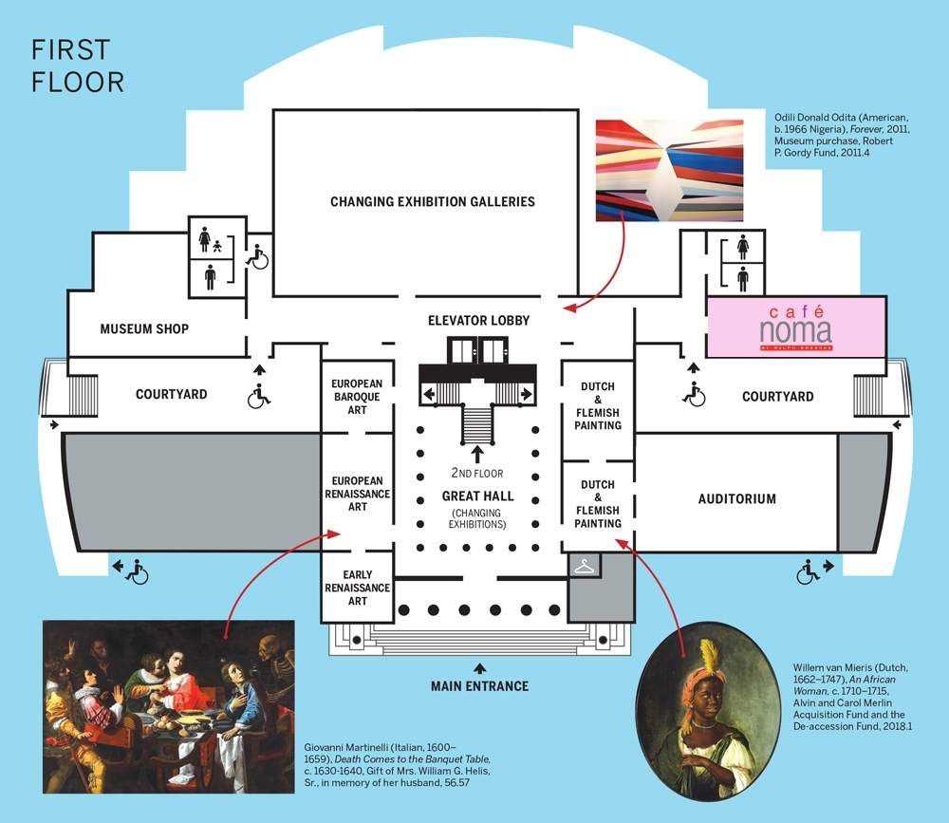
Floorplan taken from Within Walking Distance; New Orleans Museum of Art

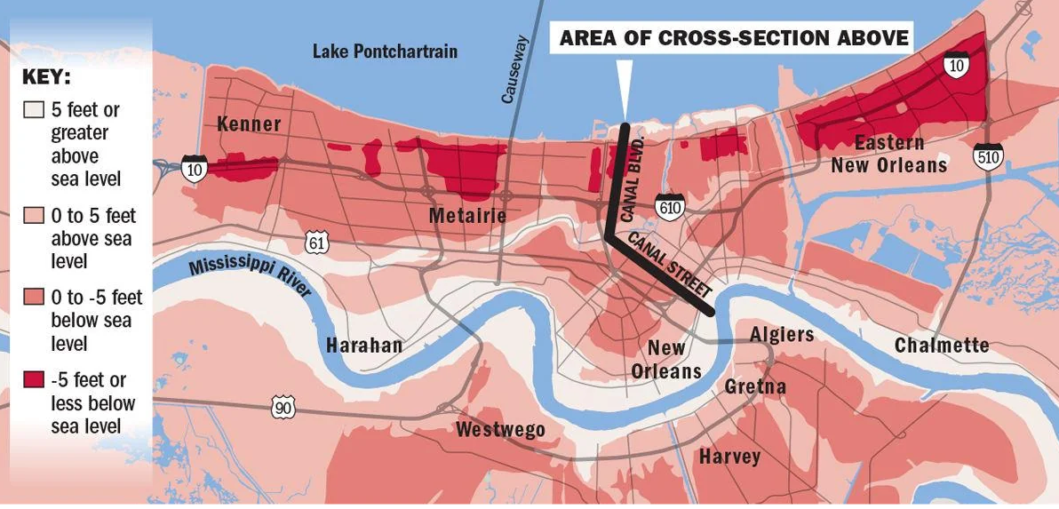
Swamplands of future New Orleans found on Reddit

To introduce the villain I create the hero’s faction:

The Green Eyed Bitches is a tribe that is mostly women and features a technology that is implanted that can change an eye’s color and provide a focus. The GEB, having raised the player with a childhood of joy and in the South of the City and along the coast in seclusion. There are dances in forests and songs and learning how to throw a spear and shoot a rifle and the player is gifted a pistol as a child and the bullets later. The player realizes they’re special. Zoning in,

“Bitches and snappers, attention!”

“Against us are the fiends who are not lead by any idea or representative. ”

“However, the fiends core method of tactics appear to be: Snipers who use trees, towers and quickly-erected stands, sometimes primed with antipersonnel ordinance. Bombings, in no discernable pattern and indiscriminately, civilian targets involved. Infrastructure though not bridges, destruction of selective grid, medical, supply lines and transformers. Traps using hand grenades, close but not on civilian infrastructure, such as in the dune grass along a hydrology bern and by a lakeside frequented by arriving NCR.”

“We do not know the fiends primary motivation, and old fiends set up fields and ranches behind the…”

The commander trailed off, in the middle of a slide of a map.

“This is strikes”

“This is identified sites”

“Successful strikes” Zoom ins: a cluster up 51 in the corner delta, a single dot off the second river bulb, near a little farm in Hahnville.”

“We don’t see a front. We believe you will be safe enough when you land, and be well aware by the time you cross the X-pass or head over near Jefferson.”

“The fiends control Metarie and patrol through Lousu. We are in a standoff with them at UNO with a small force near SOU and remain supplies to Gentilly station but cannot guarantee patrols across Road 10 and Desire. We have the pressure but can’t get any leverage no matter what we try. We do not know the situation at River bend but are applying pressure from the suburbs and the southern corridor hoping to hear word in Jefferson. Reports say settlements in seventh and south ward and monstrous things along the crater edge to the New Orleans Museum of Art so stay clear, doesn’t matter if it’s good line of sight. We think the fiends have activity on both sides of the park so if you go in straight watch for sight lines. If you make it to Lakeside Civic Center we have an informant gathering intel of Western movements.”

The commander presents sketches with and without facial hair and hairstyles of various figures.

“Some NCR are tracking a group of 37 ex-Legion officers who it is believed are aiding the fiends reign of terror; if you want to get us some currency with the Bear.”

“Today, we are meeting and being good representatives to Terrytown who will show us the river paths through the French Quarter. They will be good hosts.

“You, my group of rangers. Since you have not languished or been tried and strung up you are here and you are mine and for all of us. Be good hosts and don’t pinch rears. We have given you a lot of money to spend, spend it in good company and if you itch to brawl don’t kill the guy. Go, go and take-down, your movement is yours.

The player may improve the safety and access of communities, including ensuring free trade is establishing between Terrytown mushroom products with the rest of the wasteland and that old technology, including alien, is safely decided upon. Was it a coincidence that great storms formed around New Orleans? The player as a part of actions and general reputation can clean up the Mississippi river, including going to fight a ghoul lord who presides up the river in Nashville professing a fervent belief to make a kingdom of ghouls in the wake of a pyramid. Available early on to give the player a choice of a high-radiation environment with downstream consequences, including cleaner late-game water. Frequent warnings to the player, including by the ferry crew prior and during departure asking about any less than 30 Rad-aways in an inventory make the player aware of the consequences of being ill-prepared.

The players action has a sense in aging them. The players destiny may be set, but the timing varies across player journeys.

The Legion is destructively hostile to ghouls, but the player can use it to ascertain rank: trainees may not choose to shoot a plain wastelander, but a bark from a sergeant reveals you better watch out, and you know who calls the shots.

I imagine all Legion members may flexibly become wastelanders and will not react if you take their old armor. In addition to chaos I imagine the city and flooded districts may gain opportunity, or even heroism.

~~~

Hi, I’m Max! I’ve been wondering if the original grandmother was actually a great grandmother, being a mother of 60 before becoming a ghoul. You the character become a ghoul but you can go the whole game without becoming one, or choose to as a part of your actions or a special ceremony.

As we chase the last of a terrible creed of men and boys can we avoid becoming monsters?

In addition to writing I have a background in data science and mathematics I could use, testing ideas on sight lines and ray tracing and personality/faction rerolls and whether we can easily make variable harvestable nodes of mushrooms and other fungi that radiate out from an epicenter and grow on nodes near where they’ve been dropped. Fungi that have been cultivated to be as regenerative as doctor’s bags?

I chose New Orleans since I think it’d be cool and is a part of Americana.

